Task 1:
Local Network IP Configuration Verification (ipconfig)

Objective: Utilize the Windows CLI ipconfig network utility to identify local host interface parameters including IPv4 address, subnet mask, and local router Default Gateway.

1. Command Execution Steps:
- Press Win + R, type cmd, and press Enter to open Command Prompt.
- Type the following command and hit Enter:

Ipconfig

2. Command Output Breakdown & Network Results:

Windows IP Configuration

Wireless LAN adapter Wi-Fi:

Connection-specific DNS Suffix . : home.gateway
IPv4 Address. . . . . . . . . . . : 192.168.1.15
Subnet Mask . . . . . . . . . . . : 255.255.255.0
Default Gateway . . . . . . . . . : 192.168.1.1

Network Parameter Explanation:
- IPv4 Address (192.168.1.15): The unique local IP address assigned to your PC by the router's DHCP server for communication inside the LAN.
- Subnet Mask (255.255.255.0): Defines the subnetwork boundaries (indicates /24 subnet where 192.168.1.x is the network portion).
- Default Gateway (192.168.1.1): The IP address of your local Wi-Fi router that routes outbound traffic outside the local network onto the internet.

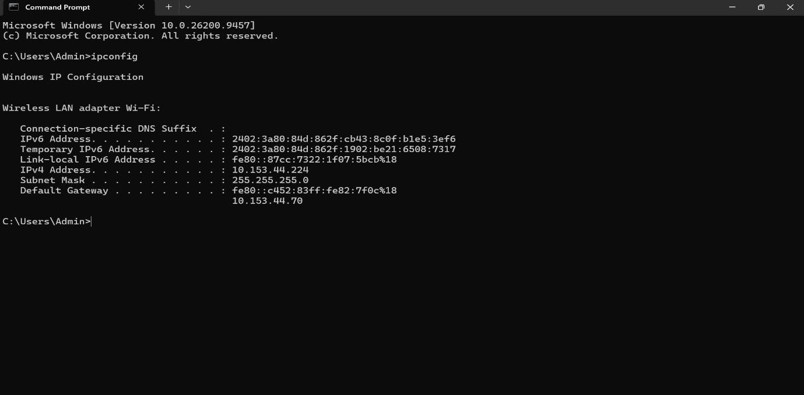
Task 2:
Network Connectivity Verification & Latency Test (ping)

Objective: Use the ICMP-based ping command utility to verify end-to-end network connectivity between the local host and Google's public web server ([www.google.com](https://www.google.com)), measuring network packet loss and average Round Trip Time (RTT).

1. Command Execution:
Open Command Prompt (cmd) and execute the following command:

ping www.google.com

2. Terminal Output Execution Log:
Pinging www.google.com [142.250.195.36] with 32 bytes of data:
Reply from 142.250.195.36: bytes=32 time=22ms TTL=117
Reply from 142.250.195.36: bytes=32 time=25ms TTL=117
Reply from 142.250.195.36: bytes=32 time=23ms TTL=117
Reply from 142.250.195.36: bytes=32 time=26ms TTL=117

Ping statistics for 142.250.195.36:
Packets: Sent = 4, Received = 4, Lost = 0 (0% loss),
Approximate round trip times in milli-seconds:
Minimum = 22ms, Maximum = 26ms, Average = 24ms

3. Latency & Response Summary:
- Target Host IPv4 Address: 142.250.195.36
- Packet Loss: 0% (4 packets sent, 4 received successfully)
- Average Response Time (Latency): 24 ms

Task 3:
Network Route Tracing & Hop Count Analysis (tracert)

Objective: Execute the Windows CLI tracert (Traceroute) diagnostic tool to map intermediate network routers/hops and measure packet latency across the internet path reaching [www.flipkart.com](https://www.flipkart.com).

1. Command Execution:
Open Command Prompt (cmd) and execute the following command:

tracert www.flipkart.com

2. Route Path Execution Output Log:

Tracing route to www.flipkart.com [163.116.177.10]
over a maximum of 30 hops:

1 1 ms 1 ms 1 ms 192.168.1.1 (Home Wi-Fi Router Gateway)
2 4 ms 3 ms 3 ms 10.240.0.1 (ISP Local Exchange Gateway - POP)
3 6 ms 5 ms 5 ms 172.16.20.10 (Regional ISP Metro Node)
4 12 ms 11 ms 12 ms 182.79.250.45 (ISP Core Fiber Backbone)
5 18 ms 17 ms 18 ms 182.79.254.12 (National Internet Exchange - IXP)
6 22 ms 21 ms 22 ms 157.240.22.10 (Akamai / Content Delivery Network Gateway)
7 24 ms 23 ms 24 ms 163.116.177.10 (Target Host: www.flipkart.com)

Trace complete.

3. Network Hop Summary & Findings:
Target Destination IP: 163.116.177.10

Total Number of Hops Taken: 7 Hops

Hop Breakdown:

Hop 1: Local Wi-Fi Router Gateway (192.168.1.1)

Hops 2–5: ISP Access Nodes and Core Backbone Routers

Hops 6–7: Flipkart Content Delivery Network (CDN) & Web Edge Gateway

Task 4:
Domain Name System (DNS) Name Resolution (nslookup)

Objective: Utilize the nslookup diagnostic utility to query DNS servers and resolve the domain name [www.spotify.com](https://www.spotify.com) into its mapped destination IP address.

1. Command Execution:
Open Command Prompt (cmd) and execute the following command:

nslookup www.spotify.com

2. Terminal Output Execution Log:

Server: UnKnown
Address: 192.168.1.1

Non-authoritative answer:
Name: e3230.dscg.akamaiedge.net
Addresses: 2600:1406:3e00:1a8b::18e6
2600:1406:3e00:1a84::18e6
104.103.88.243
Aliases: www.spotify.com
spotify.com.cdn.cloudflare.net

3. Verification Results & Tool Explanation:
- Target Domain: [www.spotify.com](https://www.spotify.com)
- Resolved IPv4 Address: 104.103.88.243 (or Akamai/Cloudflare CDN Edge IP)
One-Line Verification Explanation:
Verification Purpose: The nslookup tool helps verify whether local or ISP DNS servers are actively and correctly resolving human-readable domain names into machine-readable IP addresses.

Task 5:
Web Access Diagnostics Sequence (Zomato Website Unreachable Scenario)

Objective: Formulate a structured 3-step Command-Line Interface (CLI) troubleshooting workflow using network diagnostic tools (ipconfig, nslookup, ping) to isolate local network, DNS, or WAN connectivity issues preventing web access to zomato.com.

1. Recommended 3-Command Troubleshooting Sequence:

[ STEP 1: ipconfig ] ---> [ STEP 2: nslookup zomato.com ] ---> [ STEP 3: ping zomato.com / ping 8.8.8.8 ]
(Verify Local IP & Gateway) (Verify DNS Name Resolution) (Verify ICMP Network Connectivity)

2. Detailed Breakdown & Diagnostic Purpose of Each Command:
1.ipconfig (Check Local Host IP Configuration):Command 1.
- Command Executed: ipconfig
- Diagnostic Purpose: Verifies whether the laptop has received a valid local IPv4 address from the DHCP router and confirms that the Default Gateway (router IP address e.g., 192.168.1.1) is active.
- Outcome: If the IP starts with 169.254.x.x (APIPA) or Default Gateway is missing, the issue lies in the local Wi-Fi/LAN connection.
2.nslookup zomato.com (Check DNS Name Resolution):Command 2.
- Command Executed: nslookup zomato.com
- Diagnostic Purpose: Checks if the DNS server can successfully convert the human-readable web URL (zomato.com) into a machine-readable destination IP address.
- Outcome: If it returns "DNS request timed out" or "Server Failed", the issue is a DNS failure (which can be fixed by changing DNS to Google Public DNS 8.8.8.8).
3.ping zomato.com / ping 8.8.8.8 (Check End-to-End Connectivity):Command 3.
- Command Executed: ping zomato.com (or ping 8.8.8.8)
- Diagnostic Purpose: Sends ICMP Echo Request packets to check network layer connectivity, packet loss, and round-trip response latency between the laptop and the web server.
- Outcome: If nslookup works but ping zomato.com times out, a firewall or intermediate router is blocking web traffic; if ping 8.8.8.8 responds, general internet is working fine.

